DATE: April 11, 2002 Key SRM Contact: Jon Stine (jon_c_stine@intel.com)
BLUEPRINT VERSION: _Draft 0 v0.8________________________
SOLUTION BLUEPRINT: _PwC Consulting/Microsoft/Intel Consumer Demand Signal Service _______________
______________________________________________________________________
(Title of solution to include: Lead SI/EBSP/OEM, Lead ISV, Vertical or solution focus area, and a few descriptive words.)
These are REQUIRED/MANDATORY fields. Place N/A where not applicable.
SYSTEM INTEGRATOR: __PricewaterhouseCoopers_____________________________________
(EBSP or SI who has built this solution – name of account/company)
SI SRM NAME/NUMBER ____________________________________________________________
ENGINEERING CONTACT NAME: _Tom McMahon (tom.mcmahon@us.pwcglobal.com); Geoff Lyle (geoff.lyle@us.pwcglobal.com)
ENGINEERING CONTACT NUMBER/EMAIL _________________________________________
MARKETING CONTACT NAME: ____________________________________________________
MARKETING CONTACT NUMBER/EMAIL ___________________________________________
ISV: ___Microsoft____________________________________________________________________
ISV SRM NAME/NUMBER ____________________________________________________________
ENGINEERING CONTACT NAME: _Karen Sambogna (o) 602.569.1391 (cell) 602.290.2765__
ENGINEERING CONTACT NUMBER/EMAIL _(karengsa@microsoft.com) ____________
MARKETING CONTACT NAME: __David Walters ______________________________________
MARKETING CONTACT NUMBER/EMAIL __704.287.7216 (dwalters@microsoft.com) ____
Lead Intel TME: _Terry Cutler (terry.c.cutler@intel.com) (o) 503.677.5442 (cell) 503.475.3303 ____
Intel Senior Solution Architect: _Alan Boucher (alan.boucher@intel.com) ________________

sub: | Meeting New Market Demands
copy: | Successful retailing depends on thousands of separate but interdependent decisions, made at every level of the organization at every hour of the day and night. When data stagnates in batch processes or gets isolated in legacy systems, decision makers act on intuition, not fact. Propagation of a real-time sales data throughout the supply chain will enable Retailers and Suppliers to “better optimize, plan, and execute decisions, while improving the efficiency and utilization of their existing resources”. The Real Time Retail technical framework developed between Microsoft, Intel and PWC Consulting will address the technical challenge of responding to consumer demand in real-time by focusing on the following goals:  - Provide a migration path that allows retailers to begin laying the foundation for improved data access while the planning for the new hardware, systems and processes that will fully realize the benefits of a real time environment.  - Reduce the time it takes for sales data to propagate throughout the supply chain.  - Implement standards that will allow decision support information to freely flow between the participants in the supply chain  - Redefine planning processes to base decisions on consumer demand, allowing for optimization of the ordering and manufacturing processes that put the right product in the right place at the right time.  - Develop solutions that will scale to support the supply chain functions of the largest retailers and manufacturers in the world, to the smallest “mom & pop” retail outlet.
sub: | The Business Challenge
copy: | Agile businesses thrive by quickly realigning to new market conditions. For retailers, the timely consolidation, transformation, and distribution of transactional data within and outside of the enterprise drives this capability. Internally, transaction data supports core operational systems like replenishment, merchandising, and financials, as well as business intelligence solutions like loyalty, shrink and price optimization. Externally, manufacturers and suppliers rely on sales data to understand consumption trends, market share, and the impact of promotional activities on rates of sale.  - Discussion of the traditional problems of retail systems (legacy, lack of integration, proprietary, aging hardware)  - Disucss the features of the Biztalk engine, pos adapters , xml, messaging services  - Introduce IA features that support the MS solution (embeddedATX, Itanium, etc)  - Provide an infrastructure for data standardization, crm, kiosk, oos, demand capture, price optimzation, customer self service, portals, messaging  (Insert New Diagram with more functional representation of the services at store and enterprise level.)  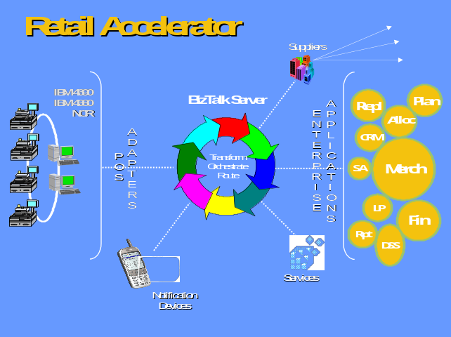
sub: | The Solution Overview
copy: | From Microsoft: What are the POS Adpater benchmarks. How many sales transactions can a biztlak sever cluster handle. How many events can the messaging service handle. What is the base server configuration. Develop a fictional retail scenario and discuss the requirements for implementation enterprise wide. (a retailer with 10 DC’s and 800 stores flows 400,000,000 items through it’s supply chain annually and has X sales per location per day, what does the solution look like for this retailer, this section will drive the cost / solution benefit section)  **** guidelines ****  2-3 Paragraphs  This section provides a description of the solution itself and what it does, from about the 10,000 feet level. This is considered the “executive summary” – if this is the only section read, the reader will understand what the solution offers and what it consists of.  - What are the key features of this solution?  - Are there any independent rankings, quotes, etc. that can be used to substantiate its performance; testing or benchmarking claims?  - What is the estimated cost of deploying the solution as documented in the architectural diagram?  - List the major functions the solution has been able to demonstrate (i.e. lowering production and transportation costs, decreasing TTM, increased profitability, etc.) Be sure to substantiate and quantify all claims.  - This is not the section to focus on company capabilities – tone and content to focus on the solution, it’s components, and value it brings to a company.  Example  Wrong: “This solution is a control center for a CRM ‘backbone’ integrating multiple data source, user groups and access channels….”  Right: “[Company name with leading application spelled out, as in this example…] IXL’s Decision Dashboard solution… utilizes the best-in-class components from Cisco/Saba, Epicentric, Lotus, Manugistics, Marcari, Oracle….By integrating these vendors within a single portal, IXL was able to demonstrate….. list provided.”
sub: | Technology
copy: | Lifted from the Real time retail white paper discuss additons to this list and prioritize the components  Intel EmbeddedATX: Economy and Flexibility for New Compact Form Factors  EmbeddedATX is a new open motherboard specification developed by Intel that promises to become the standard for space-constrained POS terminals and kiosks. Based on the popular microATX standard and backward compatible with its tooling and power connections, EmbeddedATX provides a low profile design that is ideal for thin, vertical enclosures or for placement behind a flat panel display. An expanded input/output region includes USB ports to support multiple peripherals. Internal expansion is accommodated with low-profile PCI cards. Intel expects EmbeddedATX to replace many proprietary board designs, driving down hardware costs and fueling innovation based on standardized components.  Intel® Pentium® 4 Processor Brings Streaming Media to the POS  As POS functionality expands to include customer Web browsing and streaming media delivery, the demand for processing power grows exponentially. The Intel® Pentium® 4 processor provides core speeds of up to 2.2 gigahertz (GHz) and is based Intel® Netburst® microarchitecture, designed from the ground up for high performance digital media processing. In conjunction with the EmbeddedATX specification, the Intel Pentium 4 processor delivers new levels of speed, performance and headroom to spare for future applications.  Maximum Server Power Deep in the Enterprise  In addition to the new POS platform, Intel also provides the Intel® XeonTM processors and the Intel® ItaniumTM processors that power leading enterprise servers for mid-tier and enterprise applications. Deploying a standards-based technology platform across the enterprise greatly simplifies the task of integrating the applications they support.  Intel® Architecture for the Wireless Store  Real-time tracking and response is enabled by the Intel® StrongArm™ processor, the engine “inside” industry-leading wireless devices – enabling any time, anywhere access to critical information. And the Intel® Personal Client Architecture enables wireless technology for personal shopping assistants, smart cards and line-busters – enabling the “wireless” store and turning the “point of decision” into the point of sale.  Microsoft* Windows* XP Embedded: A Robust Modular OS for Any POS Device  Microsoft has been a leader at the Point of Sale since the days of MS-DOS, and many of the more than 2.8 million POS systems sold each year ship with a Windows* operating system (OS). The recent release of Windows XP Embedded will serve to consolidate this dominance. Windows XP Embedded is a componentized and highly configurable version of the powerful Windows XP platform, designed specifically for ultra-high availability in dedicated-purpose POS devices. Because only the components required for a specific device are included in the OS implementation, storage and memory requirements are substantially reduced, lowering the hardware capital cost. An additional benefit is the lower license fee, based on the specific software modules selected and installed by the hardware vendor.  Microsoft* .NET* for Retail Streamlines XML Data Exchange  Windows XP Embedded contains complete support for Microsoft’s .NET Web services platform. This comprehensive family of clients, servers and developer tools provides swift development and deployment of Web-based applications with native support for XML (extensive mark-up language) data exchange. The .NET platform greatly simplifies the task of integrating real-time data from the POS into applications across the enterprise and beyond.  True Business Transformation – More Than Just Technology  Hardware and software alone, no matter how well crafted, do not a solution make. PwC Consulting brings one of the world’s leading retail industry management and technology consulting practices to support new POS and enterprise-wide implementations. With more than 9,000 practitioners worldwide and an unparalleled command of retail practices and information systems, PwC Consulting has the resources and expertise to drive enterprise-wide efficiencies and process change based on real-time customer and transaction data. The firm has been a pioneer in the application of CRM and SCM to the retail environment, and has established a strategic framework for customer-centric retailing.  **** guidelines ****  2-3 Paragraphs (be concise)  This section details all the components (companies, products) included in the solution, with the specific versions of the products included. Important to mention and emphasize all Intel products, platforms. Often handled best with a combination of narrative and bullet points.  - Narrative overview of technology including architecture, integration, etc.  - Call out SNMP of the server; specify what they are  - Listing of various components (i.e. OS, hardware, middleware, software)  Example  Wrong: “SilverLine leverages VoiceXML technologies to deliver interaction voice applications, bringing the ubiquity of the Web to the ubiquitous access device – the ordinary telephone….”  Right: “SilverLine’s technology is built to run on either a 2-way Intel® Pentium® 4 system running Microsoft Windows 2000 server or Linux 2.5 server…..”
sub: | Who the Solution Will Benefit
copy: | Focus on retailers the framework is separate from the perceived benefits for OOS to the CPG community.  Store Managers  Buyers / Planners  **** guidelines ****  1-2 Paragraphs  This section details the target category (horizontal) or industry(ies) vertical. Also includes detail on the target customer within the company, by title.  If more than one target customer – need to outline benefit and value for each level. This will allow us to develop marketing efforts based on the needs/concerns of the specific audience.  What are the “firmagraphics” of the target audience: industry (ie. Financial services), category (i.e. CRM), size of company, number of users, number of transactions, size of database, number of sustained hits, number of concurrent users, etc.)  Is there a particular situation that the target company finds itself in that suggests a need for this solution?  Which titles or areas within the company are likely to be interested in this solution and WHY? Be specific for each function of the company. Provide them value statements based on their concerns:  LOB: Time to market, increase sales, increase revenues, increase capacity  IT: integrating into existing infrastructures, best of breed components, compatibility, reduced risk  Example  Wrong: “Because Silverline’s VoiceXML implementation is a horizontal technology….”  Right: “Developed for companies wishing to integrate applications requiring interactive text-to-speech/voice recognition.”
sub: | Case Study / Proof Points
copy: | Possible discussion of the Meijer pilot or Fireball project? Are they seeing benefits beyond the OOS pilot. Are they utilizing the POS adapters for anything else?  *** guidelines ****  This section contains the validation and endorsements for this solution.  - Listing of companies who have deployed it (with links to case studies)  - Performance studies/benchmarks  Documentation to support the solution
sub: | Solution Benefits
copy: | **** guidelines ****  1-2 Paragraphs  This section covers key benefits the solution offers the end user. Should relate back to Section II in terms of the business challenge(s) the solution addresses.  - Is there a single broad statement of how this solution adds value for the customer/user?  - What are the key benefits (priority order) of this solution to the end-user (Ensure benefits are consistent with, and relate to, the business challenge)  - ROI – what is the end users expected ROI in deploying this solution.  - List the SRP of the components (hardware and software)  - How does the ROI of this solution compare with a competitors solution (give data, i.e. ‘can be deployed in half the time,” etc.)  - Outline all the departments/areas within a company that will benefit:  (“…. Marketing – users get enterprise and partner feedback on market, product and customer data…. Sales – users get a 360-degree view of account, product, and campaign, data driving opportunities, helping close deals…. Customers – will have ready access to their account information….”  Example  Wrong: “The Wealth Management Sector remains very attractive for IXL’s customers with forecasted market segment growth in the range of 10-20%…” (Data is good but should be placed under the business challenge.)  Right: The “[Name your company and key application here] solution:  - Lowers production and transportation costs  Lowers inventory and associated carrying costs….”
sub: | Functional Business Concept
copy: | **** guidelines *****  (This section should contain information about the various user/business requirements for the solution blueprint. Ideally, it should show a functional flow or diagram of how the stack solves all the business needs of the individual users, business processes or connection types – PDAs, Cell Phone, Wireless, PC etc; see example below:)  (In the .gif example shown below, we show the user to business process connectivity and flow within a banking application - solution blueprint.)  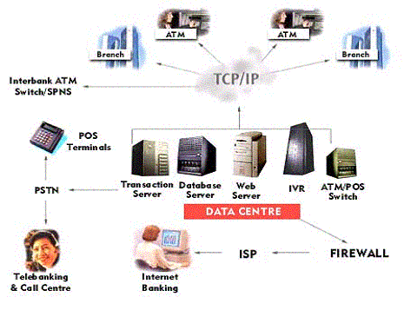  Example Only
sub: | User Experience
copy: | N/A – Not sure if this section applies to this situation
sub: | Software Architecture
copy: | **** guidelines ****  (Typically a software diagram (Visio or other) of the application stack with specific stack detail at each tier level – communication, Presentation, Compute, Compute+Data and Data tiers. The software stack should also show software interconnects for Java or .Net architectures, messaging-MQ, database connectivity, legacy application connectivity and web services integration where appropriate.)  Could be a graphic representation or a Visio Diagram: (bitmap representation of Visio Diagram shown below)
sub: | System Architecture
copy: | **** guidelines ****  (Typically a hardware design diagram (Visio or other) depicting the Tier 1-5 hardware architecture used for the stack / solution. This should/can include references to iA server types including Processor, RAM, xWay, firewalls, routing interfaces, load balancers, external SAN devices etc.. Explanations should be provided as to how the hardware is interconnected and why systems were selected for the solution. If special sizing and scaling data is available, it should also be included here.)  Should be a Visio Diagram of the systems architecture: (bitmap representation of Visio diagram shown below)  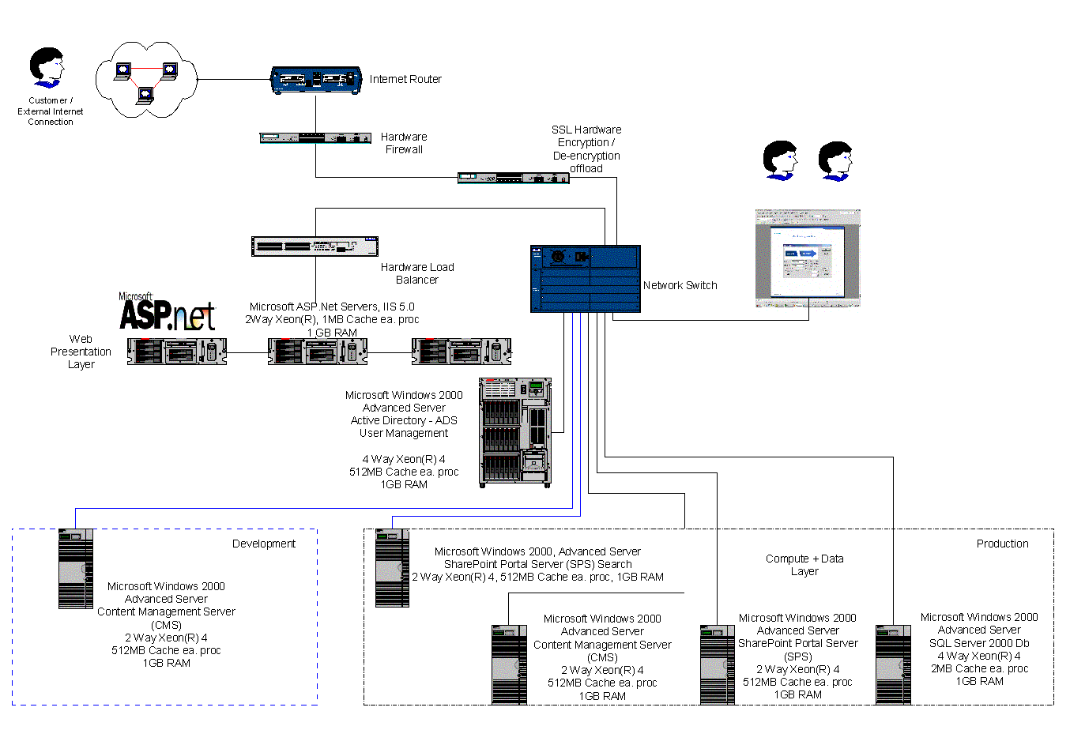  Example Only
sub: | For More Information
copy: | *** guidelines ****  This section should wrap back to the challenge section and conclude the blueprint with a summary paragraph explaining what the viewer has just seen and how the EBSP or SI solved the business problem.

